**LAPORAN E-UAS PRAKTIKUM SISTEM BASIS DATA**

Nama : Daffa Putra Alwansyah  
NIM : L200190031  
Kelas : B

Mata Kuliah : Praktikum Sistem Basis Data

Pengampu : Dedi Gunawan

Ruang, No. Kursi : HOME,13

1. Buatlah database berdasarkan kasus di atas dengan nama NamaDatabase_Nim Mahasiswa! Lalu buat tabel dan relasinya.

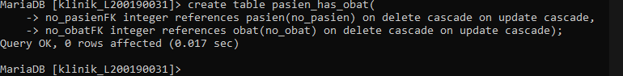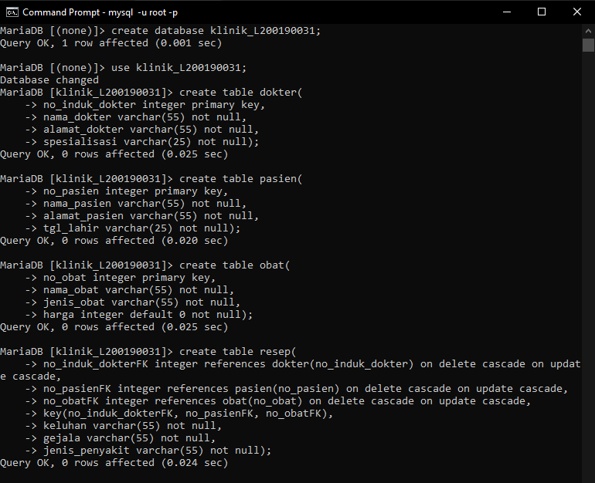

Relasi:

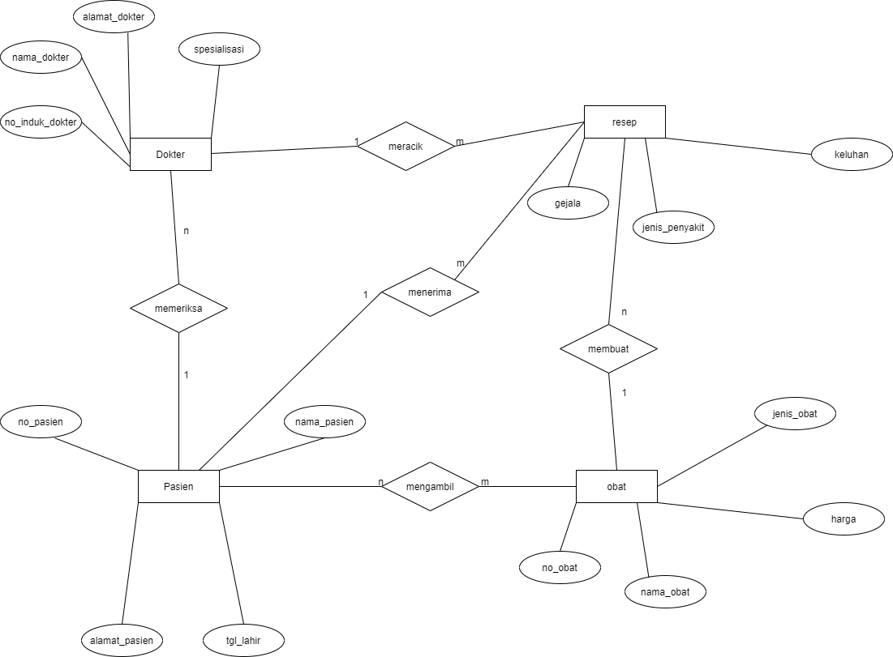

|  |  |  |  |  |
| --- | --- | --- | --- | --- |
|  | dokter | pasien | resep | obat |
| dokter |  | 1:m | 1:m | - |
| pasien | n:1 |  | 1:m | n:m |
| resep | n:1 | n:1 |  | n:1 |
| obat | - | n:m | 1:m |  |

2.Tuliskan kode program python untuk melakukan perintah INSERT data pada masing-masing tabel, dengan jumlah data pada masing-masing tabel tersebut minimal 15 record.

**dokter**import mysql.connector

try:

connection = mysql.connector.connect(user='root',database='klinik_L200190031')

mySql_insert_query = """INSERT INTO dokter (no_induk_dokter, nama_dokter, alamat_dokter, spesialisasi)

VALUES (%s, %s, %s, %s) """

records_to_insert = [(1, 'Daffa', 'Karanganyar', 'Kulit'),

(2, 'Putra', 'Gawok', 'Gigi'),

(3, 'Alwansyah', 'Solo', 'Mata'),

(4, 'Luthfi', 'Makamhaji', 'Saraf'),

(5, 'Akbar', 'Manahan', 'Bedah'),

(6, 'Taufik', 'Kluyon', 'Anak'),

(7, 'Hidayat', 'Nusukan', 'Penyakit Dalam'),

(8, 'Yudha', 'Gilingan', 'Kandungan'),

(9, 'Rama', 'Banyuanyar', 'THT'),

(10, 'Fajri', 'Mangkubumen', ' Kelamin'),

(11, 'Dimas', 'Jebres', 'Tulang'),

(12, 'Dini', 'Mojosongo', 'Jantung'),

(13, 'Sekar', 'Boyolali', 'Paru'),

(14, 'Putri', 'Laweyan', 'Pembuluh Darah'),

(15, 'Rindi', 'Tipes ', 'Trauma')]

cursor = connection.cursor()

cursor.executemany(mySql_insert_query, records_to_insert)

connection.commit()

print(cursor.rowcount, "Record inserted successfully")

except mysql.connector.Error as error:

print("Failed to insert record into MySQL table {}".format(error))

finally:

if connection.is_connected():

cursor.close()

connection.close()

print("MySQL connection is closed")

Python  
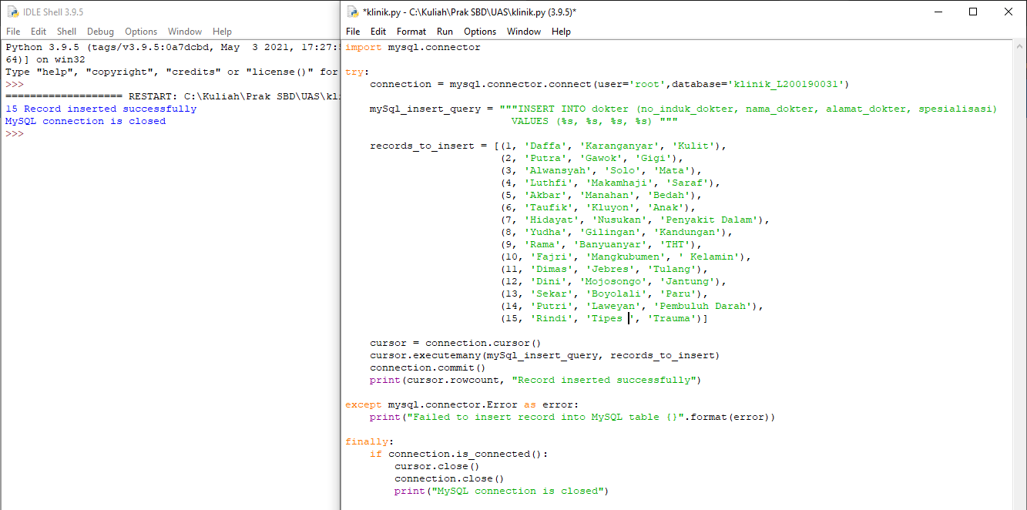  
  
CMD  
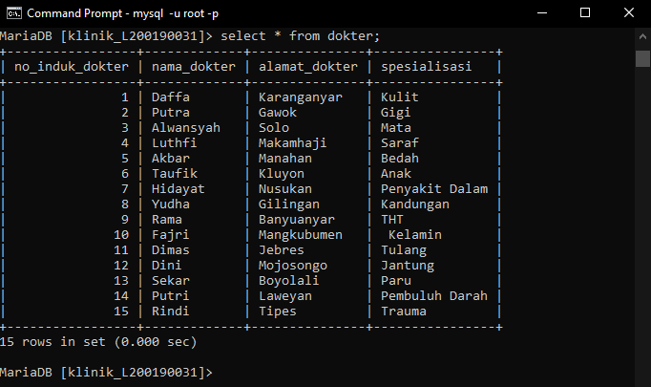

**pasien**import mysql.connector

try:

connection = mysql.connector.connect(user='root',database='klinik_L200190031')

mySql_insert_query = """INSERT INTO pasien (no_pasien, nama_pasien, alamat_pasien, tgl_lahir)

VALUES (%s, %s, %s, %s) """

records_to_insert = [(10, 'Dodit', 'Tegal', '29 Oktober 1997'),

(20, 'Ajie', 'Joglo', '28 Januari 1999'),

(30, 'Eko', 'Joyosuran', '3 Februari 2000'),

(40, 'Tyas', 'Kluyon', '5 Juni 2000'),

(50, 'Dian', 'Makamhaji', '12 Juni 2001'),

(60, 'Doni', 'Kadiporo', '23 Desember 1995'),

(70, 'Rio', 'Laweyan', '11 Juli 1994'),

(80, 'Andi', 'Kratonan', '10 November 1999'),

(90, 'Reza', 'Manahan', '16 April 1999'),

(100, 'Siti', 'Purwosari', '19 Mei 1994'),

(110, 'Nur', 'Semanggi', '20 Agustus 1992'),

(120, 'Indah', 'Serengan', '31 September 1999'),

(130, 'Agus', 'Tipes', '8 Oktober 1993'),

(140, 'Bayu', 'Pasar Kliwon', '1 November 1995'),

(150, 'Ilham', 'Serengan', '2 Desember 1998')]

cursor = connection.cursor()

cursor.executemany(mySql_insert_query, records_to_insert)

connection.commit()

print(cursor.rowcount, "Record inserted successfully")

except mysql.connector.Error as error:

print("Failed to insert record into MySQL table {}".format(error))

finally:

if connection.is_connected():

cursor.close()

connection.close()

print("MySQL connection is closed")

Python  
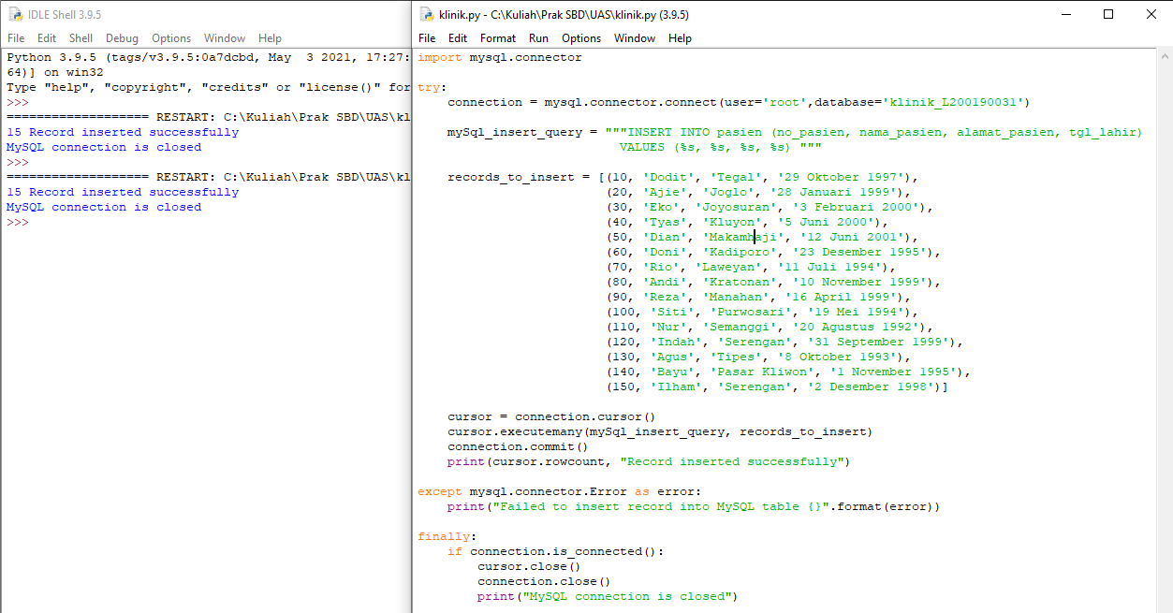  
  
CMD  
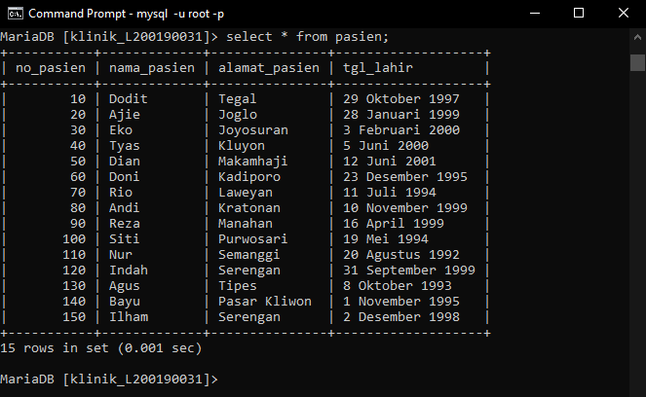

**obat**import mysql.connector

try:

connection = mysql.connector.connect(user='root',database='klinik_L200190031')

mySql_insert_query = """INSERT INTO obat (no_obat, nama_obat, jenis_obat, harga)

VALUES (%s, %s, %s, %s) """

records_to_insert = [(101, 'Acarbose', 'Serbuk', 20000),

(201, 'Acetazolamide', 'Larutan', 30000),

(301, 'Antangin', 'Larutan', 10000),

(401, 'Antibiotik', 'Larutan', 60000),

(501, 'Bodrex', 'Tablet', 15000),

(601, 'Bleomycin', 'Tablet', 25000),

(701, 'Combivent', 'Pil', 24000),

(801, 'Combantrin', 'Kapsul', 22000),

(901, 'Dermatix', 'Pil', 45000),

(1001, 'Diapet', 'Tablet', 32000),

(1101, 'Eptifibatide', 'Serbuk', 21000),

(1201, 'Etanercept', ' Kapsul', 79000),

(1301, 'Fosinopril', 'Pil', 39000),

(1401, 'Glukagon', 'Tablet', 54000),

(1501, 'Imboost', 'Tablet', 66000)]

cursor = connection.cursor()

cursor.executemany(mySql_insert_query, records_to_insert)

connection.commit()

print(cursor.rowcount, "Record inserted successfully")

except mysql.connector.Error as error:

print("Failed to insert record into MySQL table {}".format(error))

finally:

if connection.is_connected():

cursor.close()

connection.close()

print("MySQL connection is closed")

Python  
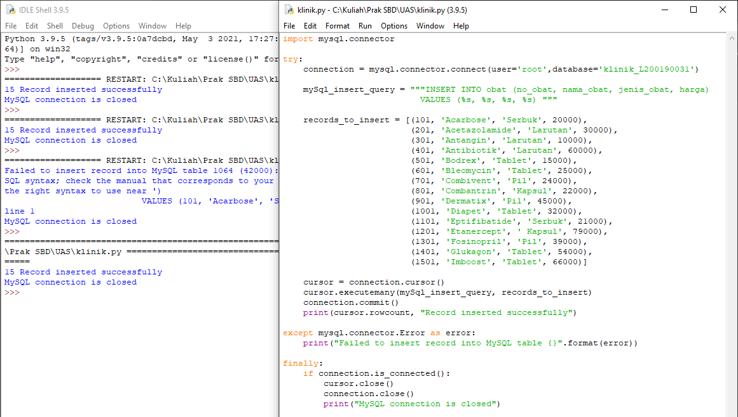  
  
CMD  
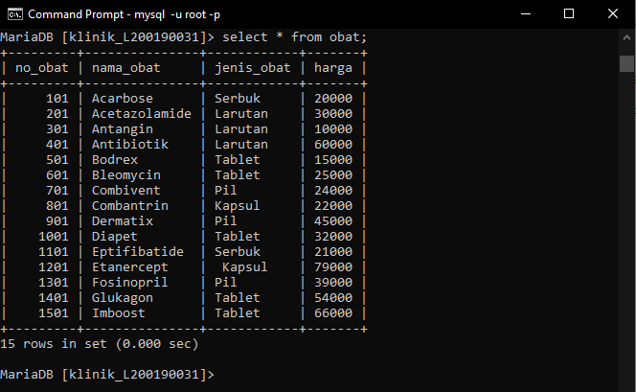

**resep**import mysql.connector

try:

connection = mysql.connector.connect(user='root',database='klinik_L200190031')

mySql_insert_query = """INSERT INTO resep (no_induk_dokterFK, no_pasienFK, no_obatFK, keluhan, gejala, jenis_penyakit)

VALUES (%s, %s, %s, %s, %s, %s) """

records_to_insert = [(1, 10, 101,'Demam', 'Batuk Kering', 'Covid 19'),

(1, 20, 201,'Pusing', 'Mual dan Muntah', 'Vertigo'),

(2, 30, 301,'Mual saat makan', 'Sakit berlebihan diperut', 'Maag'),

(3, 40, 401,'Bersin', 'Demam', 'Flu'),

(4, 50, 501,'Sesak Nafas', 'Mati Rasa', 'Jantung'),

(5, 60, 601,'Demam', 'Bersin', 'Influenza'),

(6, 70, 101,'Benjol di Anus', 'Anus Sakit', 'Wasir'),

(7, 80, 301,'Perut Sakit', 'Feses Cair', 'Diare'),

(7, 90, 1001,'Mata Sakit', 'Badan Sakit', 'Kelelahan'),

(8, 100, 1101,'Nyeri Dada', 'Batuk', 'Asma'),

(9, 110, 101,'Sakit mata', 'Batuk Kering', 'Covid 19'),

(10, 120, 1301,'Demam', 'Mata berair', 'Hipermetropi'),

(11, 130, 1401,'Benjolan di tubuh', 'Gatal Gatal', 'Cacar Air'),

(12, 140, 1201,'Panas', 'Pusing', 'Demam'),

(13, 140, 1201,'Mulut Bau', 'Gigi Kuning', 'Karang gigi')]

cursor = connection.cursor()

cursor.executemany(mySql_insert_query, records_to_insert)

connection.commit()

print(cursor.rowcount, "Record inserted successfully")

except mysql.connector.Error as error:

print("Failed to insert record into MySQL table {}".format(error))

finally:

if connection.is_connected():

cursor.close()

connection.close()

print("MySQL connection is closed")  
  
  
  
  
  
  
  
  
  
  
Python  
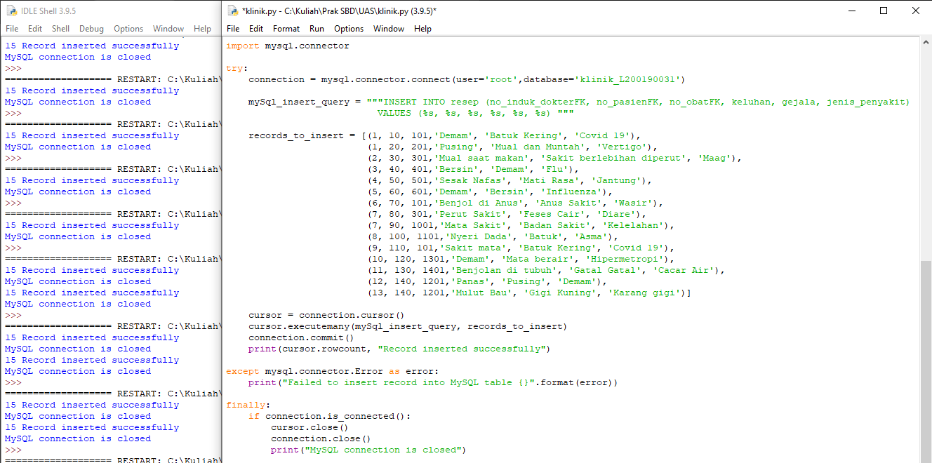  
  
CMD  
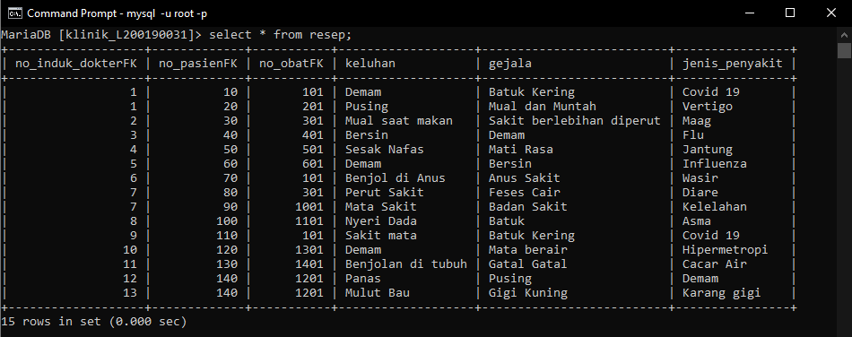

**pasien_has_obat**import mysql.connector

try:

connection = mysql.connector.connect(user='root',database='klinik_L200190031')

mySql_insert_query = """INSERT INTO pasien_has_obat (no_pasienFK, no_obatFK)

VALUES (%s, %s) """

records_to_insert = [(10,101),

(20,201),

(30,301),

(40,401),

(50,501,),

(60,601),

(70,101),

(80,301),

(90,1001),

(100,1101),

(110,101),

(120,1301),

(130,1401),

(140,1201),

(140,1201)]

cursor = connection.cursor()

cursor.executemany(mySql_insert_query, records_to_insert)

connection.commit()

print(cursor.rowcount, "Record inserted successfully")

except mysql.connector.Error as error:

print("Failed to insert record into MySQL table {}".format(error))

finally:

if connection.is_connected():

cursor.close()

connection.close()

print("MySQL connection is closed")  
  
  
  
  
  
  
  
  
  
  
  
Python  
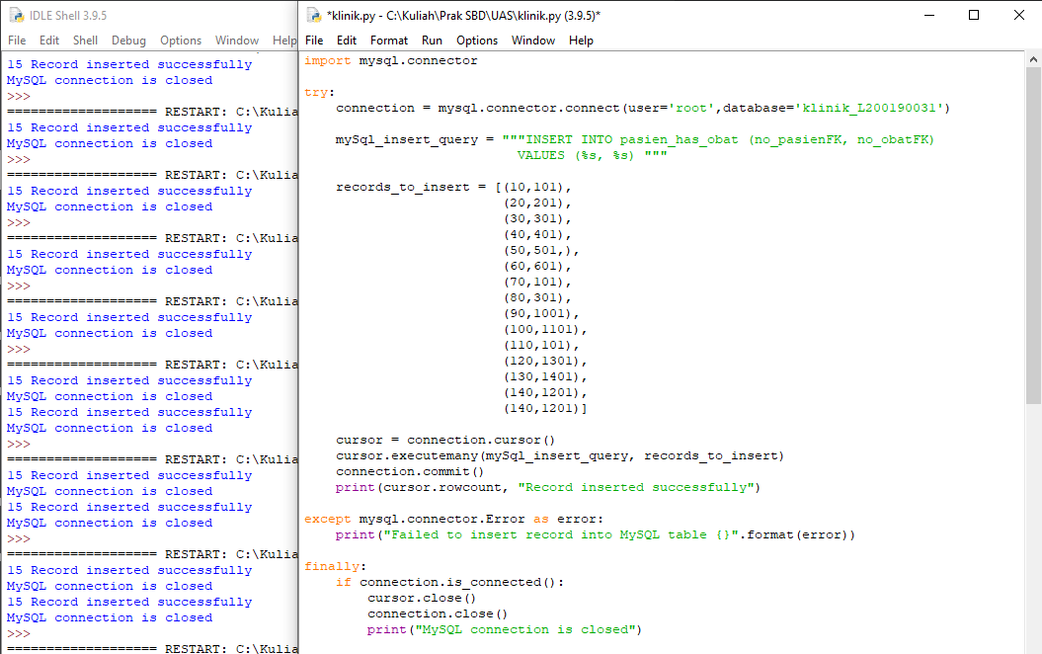  
  
CMD  
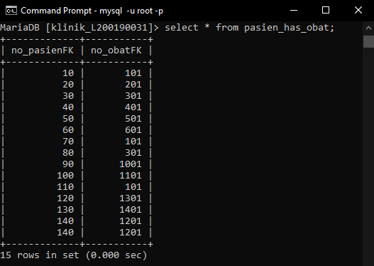

3. Buatlah join query yang bisa menampilkan nama pasien, jenis penyakit, nama

dokter, dan obat yang diberikan!

**Query:**select nama_pasien, jenis_penyakit, nama_dokter, nama_obat from pasien inner join resep on pasien.no_pasien = resep.no_pasienFK inner join dokter on resep.no_induk_dokterFK = dokter.no_induk_dokter inner join obat on resep.no_obatFK = obat.no_obat;  
 **Output:**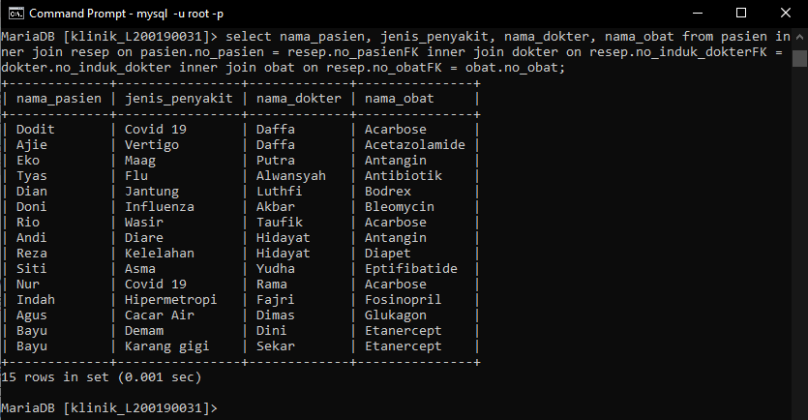

4. Buatlah query yang bisa menampilkan nama pasien dan daftar obat yang

digunakan oleh pasien tersebut serta harga total yang harus dibayarkan oleh pasien!

**Query:**  
select pasien.nama_pasien, obat.nama_obat, obat.harga from pasien inner join pasien_has_obat on pasien_has_obat.no_pasienFK = pasien.no_pasien inner join obat on pasien_has_obat.no_obatFK = obat.no_obat;  
  
**Output:**

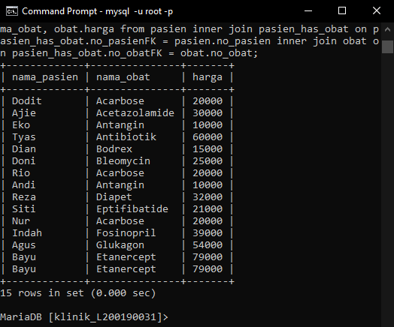  
  
5. Buatlah query beserta sub query yang dapat menampilkan nama pasien yang mengkonsumsi obat paling banyak serta memiliki total harga obat yang paling tinggi!  
  
select pasien.nama_pasien as "Nama Pasien", SUM(obat.harga) as "Total Harga Obat", COUNT(obat.nama_obat) as "Jumlah Obat" from pasien inner join pasien_has_obat on pasien_has_obat.no_pasienFK = pasien.no_pasien inner join obat on pasien_has_obat.no_obatFK = obat.no_obat where obat.harga = (SELECT MAX(harga) from obat);  
  
